Team JRKI

Dashboard Instruction Manual
Team JRKI 2025

1.0 Table of Contents
1.0 Table of Contents 1
2.0 Before Setup 2
3.0 Dashboard Overview 3
4.0 Main Filters 4
5.0 Line Charts - Visualisation 5
6.0 Selected Display box 7
7.0 Bottom Tabs 8
8.0 Naming References - Used for the Dashboard 9

2.0 Before Setup

This dashboard operates entirely on your local machine using Power BI Desktop (free version), requiring no cloud connection or external databases. The most critical setup step is updating the RootFolder parameter to match where you save the project folder on your computer, this single parameter tells Power BI where to find all data files. This can be accessed through the Transform Data window.

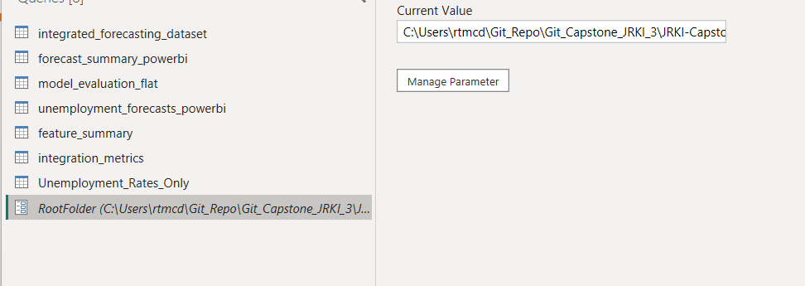

The dashboard imports three essential

CSV files:
- “integrated_forecasting_dataset.csv” (historical data)
- “unemployment_forecasts_powerbi.csv” (forecasts)
- “model_evaluation_flat.csv” (accuracy metrics)

Additionally, the dashboard uses a “stats_nz_powerbi_theme.json” file to maintain consistent colors and styling across all visualizations.

Critical Dependency on Stats NZ Naming Conventions: This dashboard is specifically engineered to work with Stats NZ's current column naming structure as of October 2025.If Stats NZ changes their data export format, modifies column names, or restructures their dataset schema in future releases, the dashboard will fail to refresh and display error messages. Any updates to the underlying data structure from Stats NZ would require corresponding updates to the Power Query code and data model within the dashboard. Organizations using this dashboard long-term should be prepared to perform maintenance updates if Stats NZ alters their data conventions, or work with the development team to adapt the dashboard to new formats.

3.0 Dashboard Overview

This interactive Power BI dashboard visualizes the unemployment rate trends and forecast projections in New Zealand

It allows users to filter and view unemployment rates based on:

- Age Group
- Ethnicity
- Gender

The dashboard displays both historical data and over eight quarters (two years).

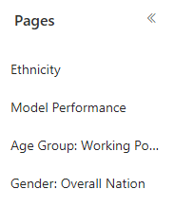
Navigation Panel (Left Side)
Use the navigation menu to move between different sections of the dashboard:

- Ethnicity: Trends by ethnic groups.
- Model Performance: Model performance and accuracy
- Age Group: Working population, trends by different age groups
- Gender: Overall nation, view national unemployment trends by gender

4.0 Main Filters

Based on the page you are on, the top right corner of the dashboard provides sliders that allow you to filter specific demographics.
- Note: Cltr + Click can selete multiple lines on a Line Chart.

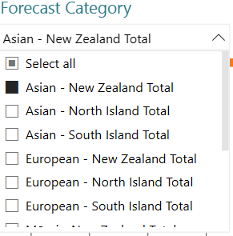
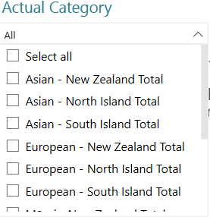

5.0 Line Charts - Visualisation

- Actual (Historical) Unemployment Rate (Left Chart)

- Displays the actual unemployment rate trend over the past years
- X-Axis: Timeline By year.
- Y-Axis: Unemployment rate (percentage)
- Use the hover feature: Move your cursor over any data point to see
- The exact average unemployment rate
- The year/quarter it represents
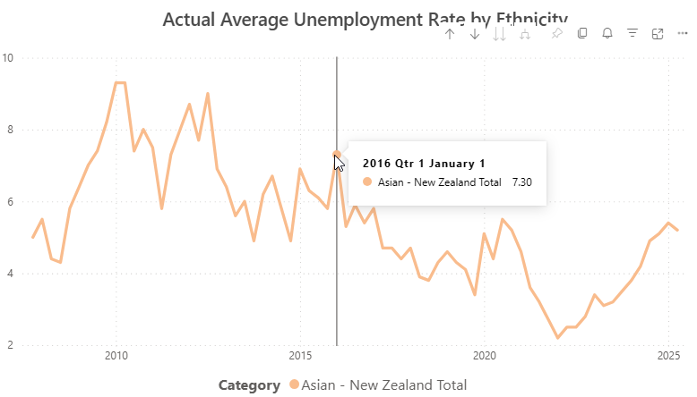

- Forecasted Unemployment Rate (Right Chart)

- Displays the forecasted unemployment rates for the next two years.
- X-Axis: Timeline By year.
- Y-Axis: Unemployment rate (percentage)
- Use the hover feature: Move your cursor over any data point to see
- Confidence Interval Upper - the higher boundary of the forecast range (maximum expected unemployment rate)
- Average Unemployment Rate - The forecasted average unemployment rate of the Categories Dataset
- Confidence Interval Lower - The lower boundary of the forecast range (minimum expected unemployment rate.
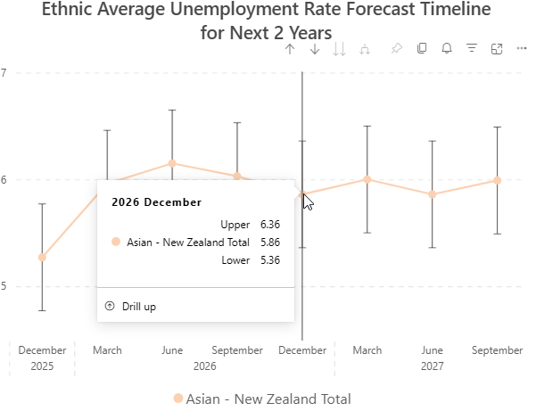

6.0 Selected Display box

Below each line graph is a Selected Display box. This box displays the information regarding the selected point as seen in images 3.0 Line Charts - Visualisation.

- Actual (Historical) Unemployment Rate (Left Chart)

- Displays Name of the selected dataplot
- Displays the period of selected dataplot (quarter, month, and year)
- Displays the Average Unemployment rate (percentage) of select dataplot
- Use the hover feature: Move your cursor over any data point to see

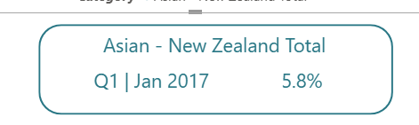

- Forecasted Unemployment Rate (Right Chart)

- Displays Name of the selected dataplot
- Displays the period of selected dataplot (quarter, month, and year)
- Displays the Average Unemployment rate (percentage) of select dataplot
- Displays Confidence Interval of the selected dataplot
- Confidence Interval Upper - the higher boundary of the forecast range (maximum expected unemployment rate)
- Average Unemployment Rate - The forecasted average unemployment rate of the Categories Dataset
- Confidence Interval Lower - The lower boundary of the forecast range (minimum expected unemployment rate.
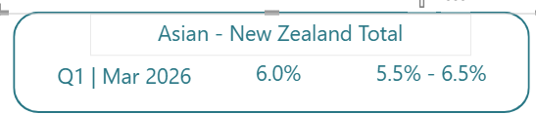

7.0 Bottom Tabs

Bottom Tabs - Allows a navigator to other pages that sees the other Breakdown dataset of the main Demographic. Each of Main Demographic (refer to Overview 1) main pages has their own Bottom Tabs unique to it.

Notes: Some of these tabs will take you to a different Main Demographic Page due to the overlap in the Dataset.

Example: below is the Ethnicity Main Page. Use these tabs to switch views:

- Nation Wide: Average Unemployment Rate of the Ethic Groups at a National level.
- European Regional Council: Average Unemployment Rate of the Europeans at a Regional Council level.
- Maori Regional Council: Average Unemployment Rate of the Europeans at a Regional Council level.
- Pacific People Regional Council: Average Unemployment Rate of the Pacific People at a Regional Council level.
- Asian Regional Council: Average Unemployment Rate of the Asian at a Regional Council level.
- Gender by Ethnicity: Average Unemployment Rate of the Ethnicity by Gender. Note: this tab will take you to the Gender Main Demographic Page.

